EXPT NO: 5 | IMPLEMENTATION OF A RECURRENT NEURAL NETWORK (RNN) FOR TEXT GENERATION
DATE: 24-08-2024

PRE-LAB QUESTIONS

- Explain the purpose of a Recurrent Neural Network (RNN) in processing sequential data.
An RNN is designed to process sequential data by maintaining information from previous inputs. It uses this information to understand patterns and relationships over time, making it suitable for sequences such as text, speech, and time-series data.

- Why is an RNN considered an appropriate model for text generation tasks?
Text consists of words arranged in a sequence, where the meaning of a word often depends on previous words. An RNN can remember information from earlier words and use it to predict the next word, making it suitable for text generation.

- Describe the concept of sequence modeling in natural language processing.
Sequence modeling is the process of learning patterns and relationships within an ordered sequence of words or tokens. In NLP, it helps a model understand the context and predict the next word or other elements in a sentence.

- Explain the importance of tokenization during text preprocessing for RNN-based text generation.
Tokenization divides text into smaller units called tokens, such as words or characters. These tokens allow the text to be processed systematically and converted into a format that can be used for generating input sequences for an RNN.

- Explain the significance of converting text into numerical representations before training an RNN.
Neural networks cannot directly process text. Therefore, words must be converted into numerical representations, such as integer indices or embeddings. These numerical values allow the RNN to perform mathematical computations and learn patterns from the text.

AIM
To implement a Recurrent Neural Network (RNN) for text generation and evaluate its ability to generate meaningful text by predicting the next word in a sequence.

SOFTWARE REQUIREMENTS
- Python
- TensorFlow or keras or PyTorch
- Google Colab
- GitHub
- Numpy
- Matplotlib

OBJECTIVES
Students will be able to:
- Understand the architecture and working of Recurrent Neural Networks (RNNs).
- Perform text preprocessing techniques for sequence modeling.
- Generate input sequences suitable for training an RNN model.
- Build and train an RNN model for text generation.
- Generate text by predicting the next word in a sequence.
- Evaluate the performance of the trained RNN using generated text.
- Analyze the effectiveness of RNNs in learning sequential patterns from textual data.

PROCEDURE
PART A: DATASET PREPARATION
Perform the following tasks:
- Load the Tiny Shakespeare dataset from Hugging Face.
- Explore the dataset and examine the text samples.
- Convert the text into lowercase (if required).
- Tokenize the text into individual words.
- Build a vocabulary and assign a unique integer index to each word.
- Generate input sequences for next-word prediction.
- Apply sequence padding to obtain inputs of equal length.
- Split the prepared sequences into training and validation datasets.

Screenshots :

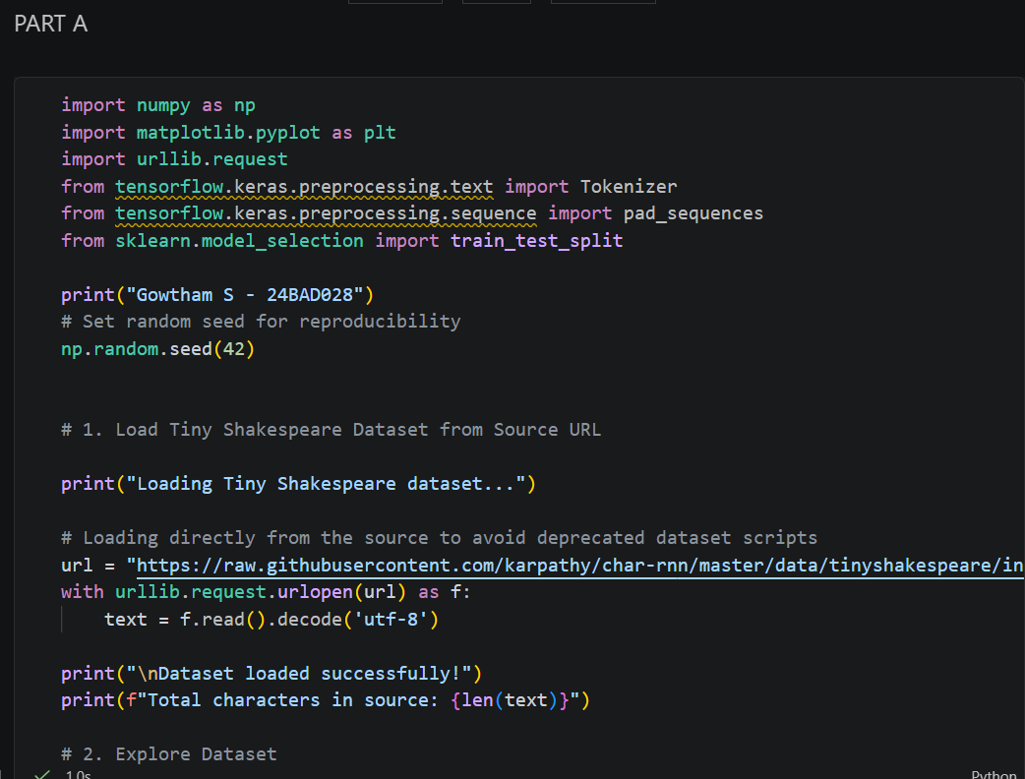
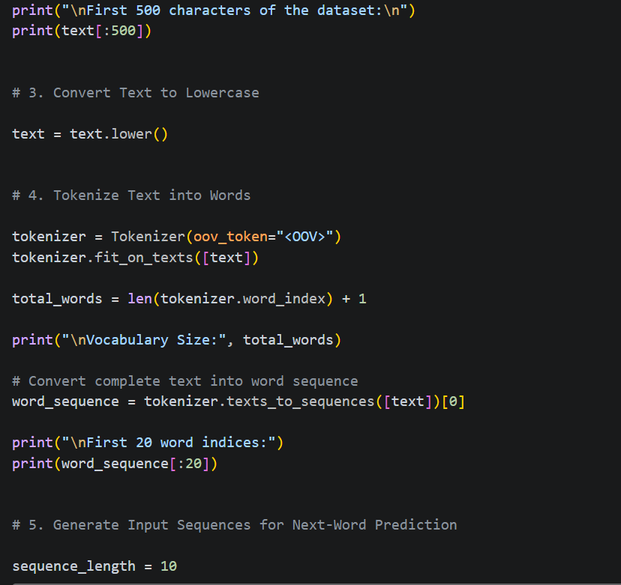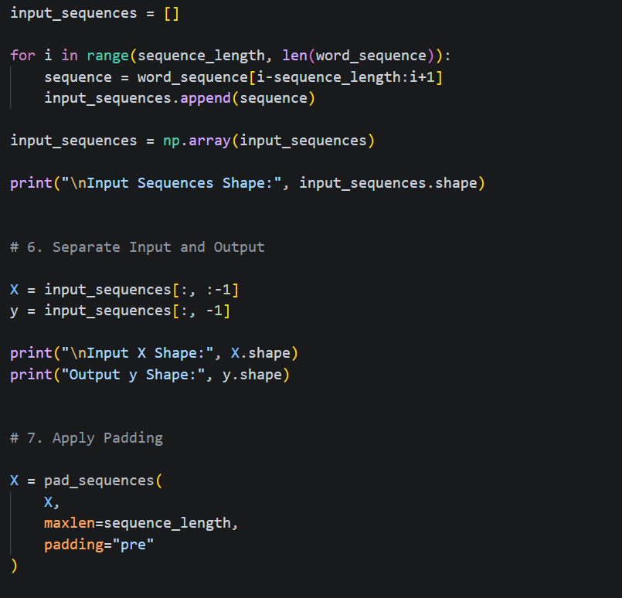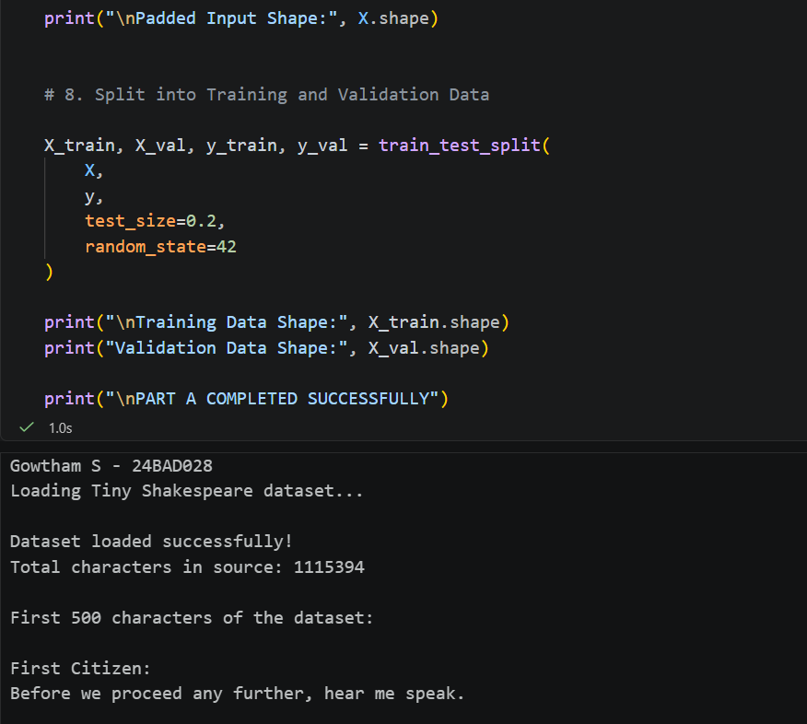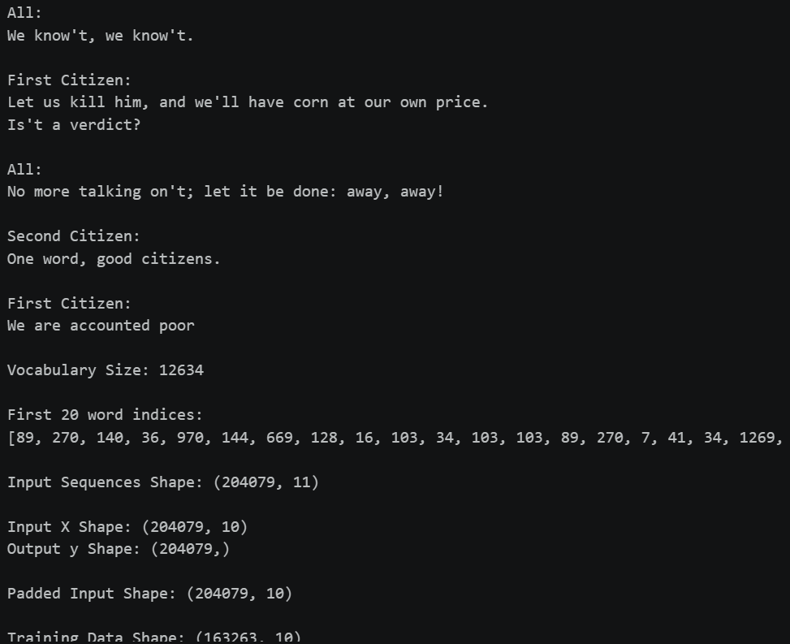

PART B: IMPLEMENTING THE RNN MODEL
Perform the following tasks:
- Create an Embedding layer to convert words into dense vector representations.
- Add a Simple RNN layer to learn sequential dependencies in the text.
- Add a Dense output layer with Softmax activation for next-word prediction.
- Compile the model using an appropriate optimizer and loss function.
- Display the model architecture and summary.

Screenshots :

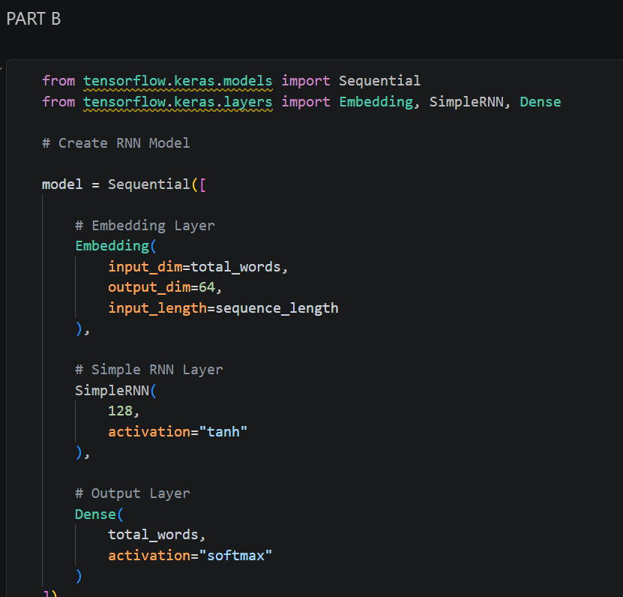
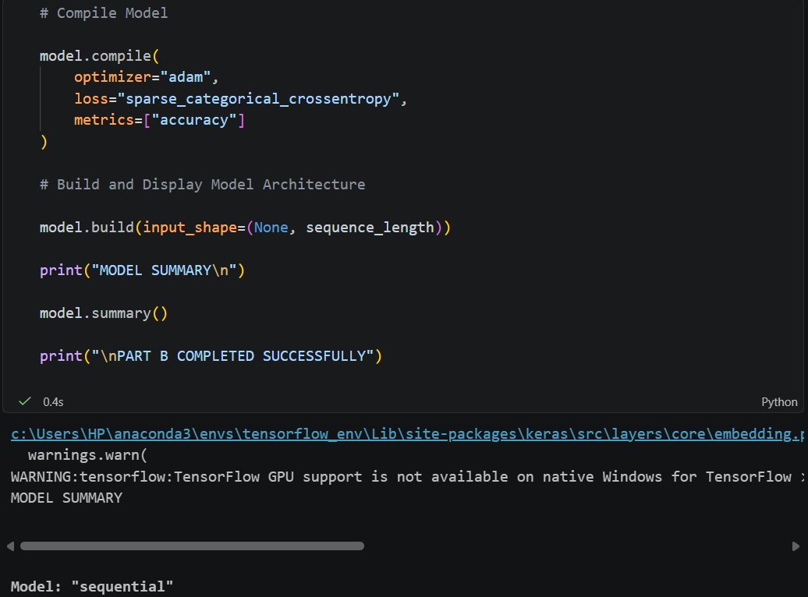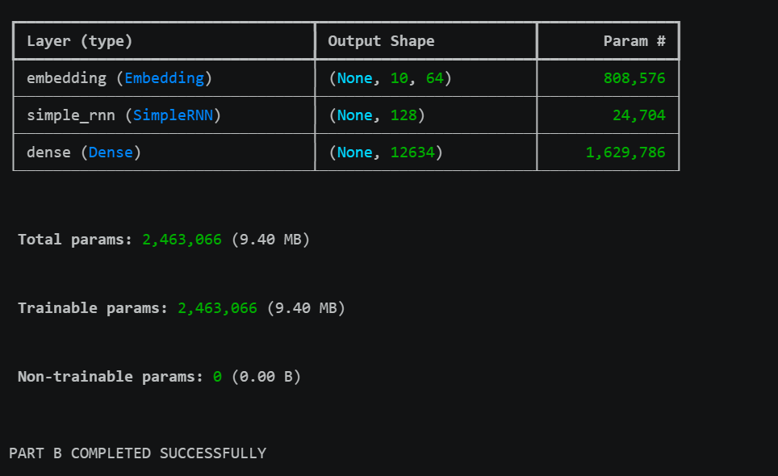

PART C: COMPARISON OF OPTIMIZATION ALGORITHMS
Perform the following tasks:
- Train the RNN model using the prepared training dataset.
- Validate the model using the validation dataset.
- Record:
  - Training accuracy
  - Validation accuracy
  - Training loss
  - Validation loss
- Visualize:
  - Accuracy vs. Epoch
  - Loss vs. Epoch

Screenshots :

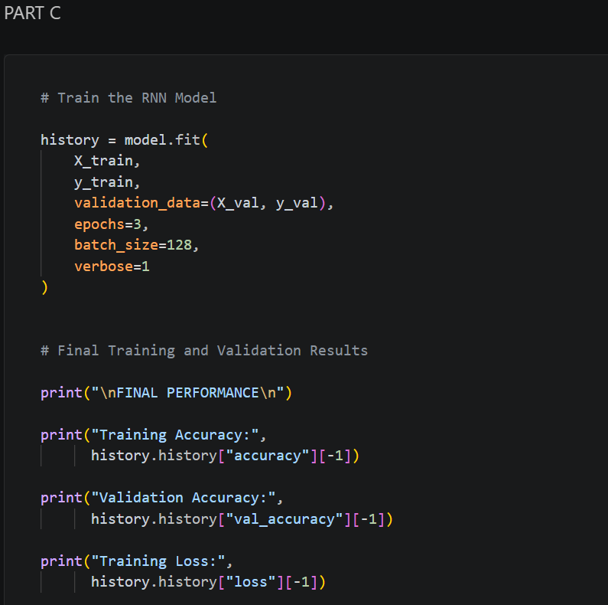
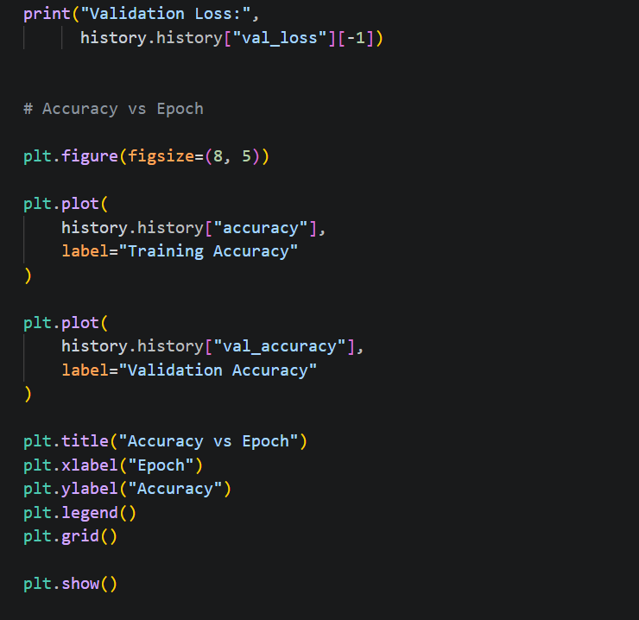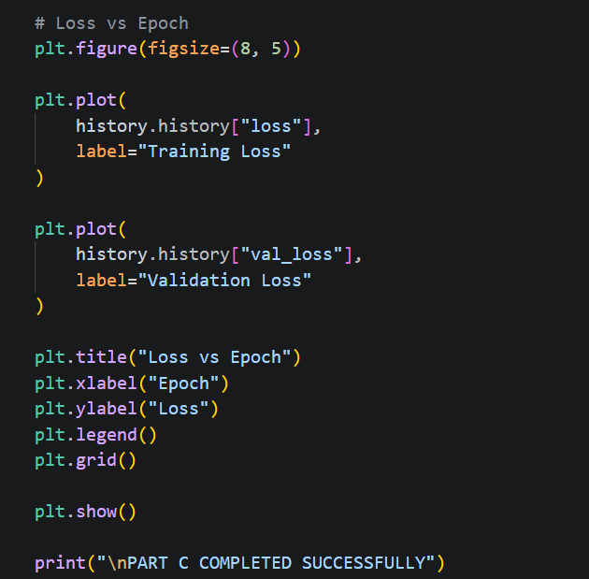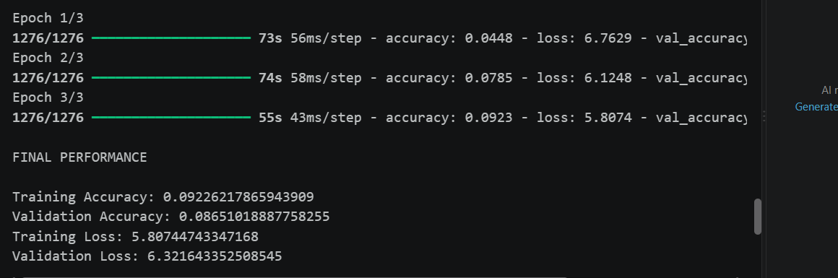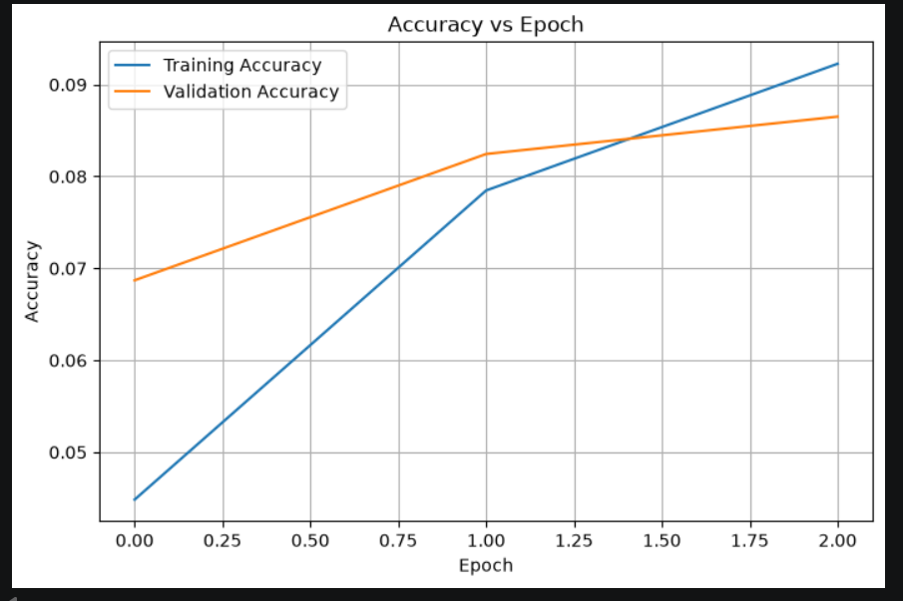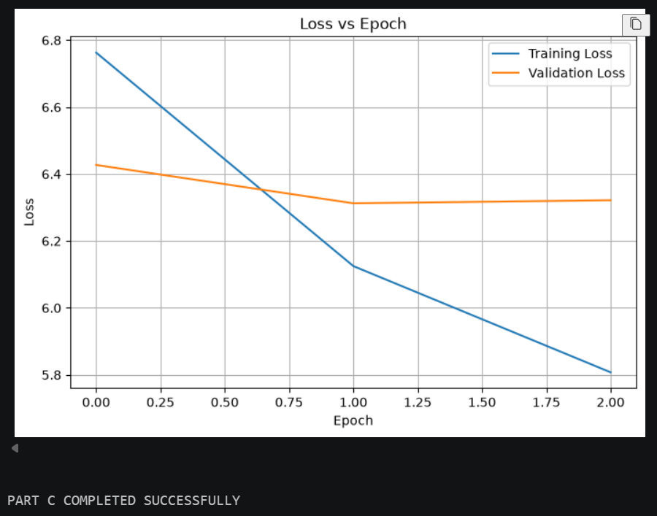

PART D: DEEP LEARNING EXPERIMENT MANAGEMENT
Perform the following tasks:
- Provide a seed word or sentence as input to the trained model.
- Generate text by repeatedly predicting the next word in the sequence.
- Produce multiple text samples using different seed inputs.
- Compare the generated text for coherence and contextual relevance.
- Document the observations and upload the notebook to GitHub.

Screenshots :

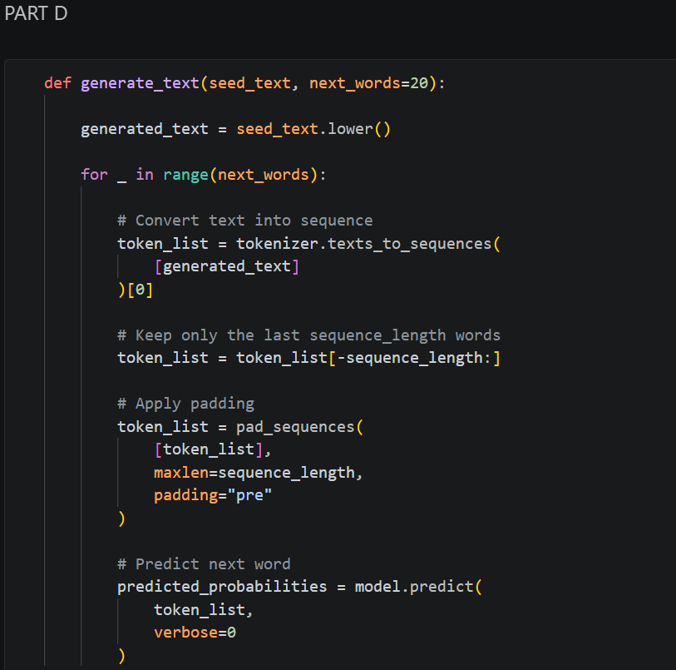
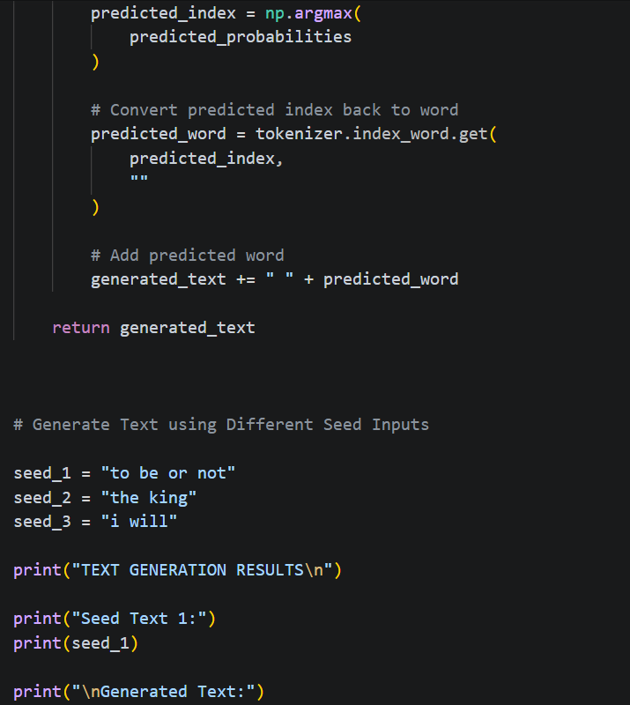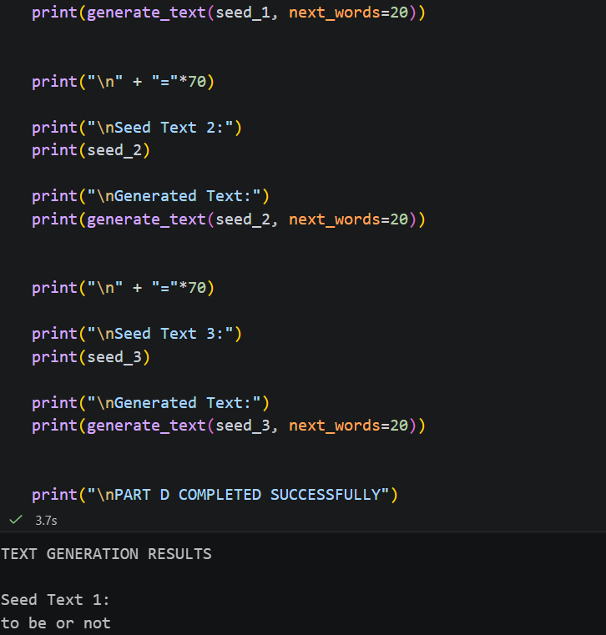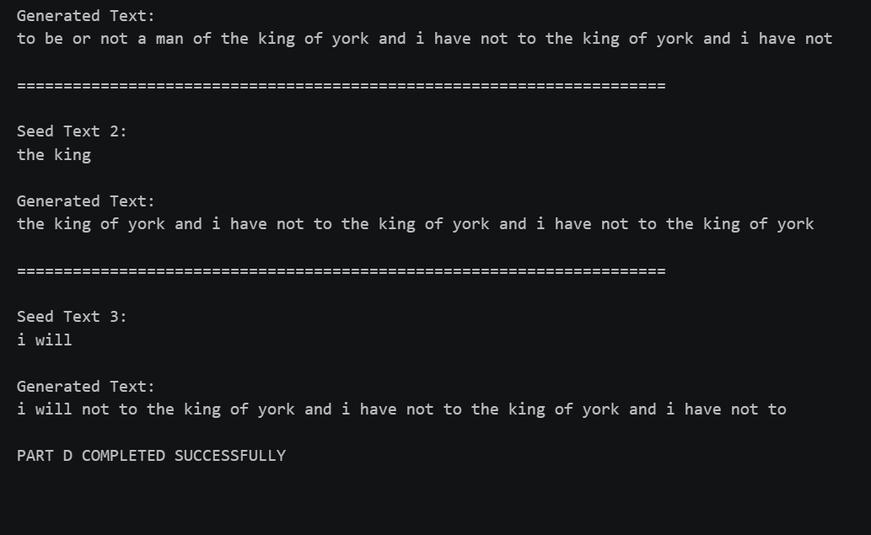

EXPECTED OUTCOME
Students will understand how an RNN learns sequential information and generates meaningful text based on previously learned patterns. Students will learn to preprocess textual data and train a Recurrent Neural Network (RNN) for text generation. They will evaluate the model's performance using training metrics and generate text through next-word prediction.

POST-LAB QUESTIONS

- Describe the role of the hidden state in an RNN during sequence processing.
The hidden state acts as the memory of the RNN. It stores information from previous inputs and passes this information to the next step, helping the model understand the context of the sequence.

- Discuss the effect of training an RNN model for an insufficient number of epochs.
If an RNN is trained for too few epochs, it may not learn the important patterns in the dataset. This can result in underfitting, low accuracy, high loss, and poor-quality generated text.

- Explain the purpose of padding when preparing text sequences for RNN training.
Padding is used to make all input sequences the same length. This allows the sequences to be processed efficiently in batches and ensures that the RNN receives inputs with a consistent shape.

- Discuss one limitation of a Simple RNN when processing long text sequences.
A major limitation of a Simple RNN is its difficulty in remembering information from earlier parts of a long sequence. It can suffer from the vanishing gradient problem, which makes learning long-term dependencies difficult.

- Discuss the effect of sequence length on the performance of the text generation model.
Sequence length determines how much previous context the model uses to predict the next word. A very short sequence may provide insufficient context, while a very long sequence can increase computational complexity and may make training more difficult. Therefore, an appropriate sequence length helps improve text generation performance.

ASSESSMENT
Description | Max Marks | Marks Awarded
Pre Lab Exercise | 5
In Lab Exercise | 10
Post Lab Exercise | 5
Viva | 10
Total | 30
Faculty Signature

